Cryptocurrency Trend Analysis

**Team Members** : Korlapati Pravallika Surya

Datla Sravani

Sneha Keerthi kona

Arun Kumar Vadlana

T.Lakshmianth

**Date**  : June , 2025

**Table of Contents**

1. Introduction
2. Dataset Description
3. Tools and Libraries Used
4. Data Preprocessing
5. Trend Analysis
6. Statistical Insights
7. Prediction
8. Conclusion
9. References
10. Appendix

**1. Introduction**

**1. Introduction to Cryptocurrency**

**🪙 What is Cryptocurrency?**

Cryptocurrency is a **digital or virtual currency** that uses **cryptographic techniques** for secure financial transactions. Unlike traditional currencies issued by central governments (called fiat currencies), cryptocurrencies operate on **decentralized networks**, typically based on **blockchain technology**.

The term “crypto” refers to the use of **cryptography**—a method of protecting information and securing communication—to control the creation of new coins and verify transactions.

**📜 Historical Background**

* The concept of digital currency dates back to the 1980s, but it was **Bitcoin**, introduced in **2009 by an anonymous individual or group known as Satoshi Nakamoto**, that revolutionized the financial landscape.
* Bitcoin introduced a **peer-to-peer electronic cash system**, enabling people to send money directly to one another without the need for intermediaries like banks.

Since then, thousands of alternative cryptocurrencies (called **altcoins**) have been developed, such as Ethereum, Ripple, Litecoin, and Cardano—each offering different features and use cases.

**🔗 Key Characteristics**

* **Decentralization**: No central authority controls the network. Instead, it is maintained by a distributed community of participants (nodes).
* **Transparency**: All transactions are recorded on a public ledger (blockchain), visible to anyone.
* **Immutability**: Once a transaction is recorded, it cannot be altered or deleted.
* **Security**: Cryptography ensures that transactions are secure and participants are anonymous or pseudonymous.
* **Global Accessibility**: Cryptocurrencies can be sent and received across borders without intermediaries or government oversight.

**🧠 How Does It Work?**

At the core of cryptocurrencies is the **blockchain**, a **distributed ledger** that records all transactions across a network of computers.

**🔐 A Basic Crypto Transaction Involves:**

1. **Wallets**: Users store their crypto in digital wallets (software or hardware-based).
2. **Public and Private Keys**: Each wallet is secured by a pair of cryptographic keys. The public key is like an address, and the private key is like a password.
3. **Miners/Validators**: They confirm transactions and add them to the blockchain. In Bitcoin, this is done through **Proof of Work (PoW)**. Other cryptocurrencies use **Proof of Stake (PoS)** or more efficient consensus mechanisms.

**🔄 Common Use Cases**

* **Investment and Trading**: People buy and sell cryptocurrencies for profit.
* **Decentralized Finance (DeFi)**: Enables lending, borrowing, and interest-earning without banks.
* **Smart Contracts**: Self-executing contracts that run on platforms like Ethereum.
* **Cross-border Payments**: Faster and cheaper international transfers.
* **NFTs (Non-Fungible Tokens)**: Digital assets representing ownership of art, music, and more.

**📈 Growth and Adoption**

* The total cryptocurrency market cap has surpassed **$1 trillion**, with Bitcoin and Ethereum being the most dominant.
* Companies like **Tesla**, **PayPal**, and **Visa** have started integrating crypto-related services.
* Several countries have begun exploring or launching their own **Central Bank Digital Currencies (CBDCs)**.

**⚠️ Challenges**

* **Regulatory uncertainty**: Different governments treat crypto in different ways—some welcome it, others ban it.
* **Security threats**: Exchanges and wallets can be hacked.
* **Volatility**: Prices can fluctuate wildly in short periods.
* **Environmental concerns**: Proof-of-Work systems consume significant energy (though newer systems aim to reduce this).

**🔮 The Road Ahead**

The future of cryptocurrency lies in:

* **Mainstream adoption**
* **Improved scalability and energy efficiency**
* **Integration with Artificial Intelligence and the Internet of Things (IoT)**
* **Legal frameworks to balance innovation and consumer protection**

**Objective:**

The primary objective of this document is to provide a **comprehensive and analytical understanding of cryptocurrency trends**, spanning from the fundamental concepts of digital currencies to the complex dynamics that influence market behavior in the ever-evolving crypto ecosystem. As the cryptocurrency landscape continues to expand rapidly, it becomes imperative to not only grasp the basic mechanisms behind digital assets but also to critically analyze their growth, volatility, adoption patterns, regulatory responses, and technological innovations. This report aims to serve as an in-depth exploration into these dimensions, enabling readers to gain both a foundational and advanced understanding of cryptocurrency and its real-world implications.

### Key Objectives Include:

1. **To Define and Demystify Cryptocurrency:**
   * Introduce the concept of cryptocurrency, tracing its historical development, technological framework, and key terminology.
   * Explain core components such as blockchain, mining, consensus algorithms, wallets, and transaction validation processes.
2. **To Classify and Compare Different Types of Cryptocurrencies:**
   * Highlight major cryptocurrencies like Bitcoin, Ethereum, and newer altcoins, analyzing their unique purposes, use cases, and technological distinctions.
   * Understand the role of stablecoins, utility tokens, memecoins, and Central Bank Digital Currencies (CBDCs) in the broader digital economy.
3. **To Analyze Market Trends and Volatility Patterns:**
   * Perform a historical and contemporary review of market capitalization, price trends, volume fluctuations, and trading behavior.
   * Identify macroeconomic, political, and socio-cultural factors influencing bullish and bearish market cycles.
4. **To Explore Technological Innovations in the Crypto Space:**
   * Delve into the evolution of blockchain technologies, Layer 1 and Layer 2 solutions, scalability challenges, and the role of smart contracts.
   * Investigate emerging trends like Decentralized Finance (DeFi), Non-Fungible Tokens (NFTs), and the integration of Artificial Intelligence with blockchain.
5. **To Examine Global Regulatory Landscapes:**
   * Outline and compare the regulatory approaches adopted by different nations and regions including the United States, India, China, and the European Union.
   * Understand the impact of regulatory uncertainty on investor sentiment, innovation, and market stability.
6. **To Identify Opportunities and Risks:**
   * Provide insights into the potential benefits of cryptocurrency in areas such as financial inclusion, digital identity, and global remittances.
   * Analyze the risks including security vulnerabilities, fraud, illicit use, technological failures, and market manipulation.
7. **To Present Data-Driven Insights:**
   * Use visualizations (charts, graphs, and tables) to support trend analysis and simplify complex data.
   * Leverage real-time and historical data from reputed sources to validate findings and predictions.
8. **To Forecast the Future of Cryptocurrency:**
   * Predict possible future scenarios for the crypto industry based on technological, economic, and regulatory developments.
   * Assess the potential for cryptocurrency to become a mainstream financial instrument, disrupt existing financial systems, and drive the digital economy forward.
9. **Dataset Description**

For an effective trend analysis of the cryptocurrency market, reliable and comprehensive datasets are essential. This report utilizes **time-series data** from reputed sources to analyze the performance, volatility, and adoption trends of leading cryptocurrencies such as Bitcoin, Ethereum, and select altcoins. The datasets cover a wide range of market indicators including price, trading volume, market capitalization, circulating supply, and social sentiment metrics.

**📊 Key Data Sources**

1. **CoinMarketCap** – Provides historical and live data on thousands of cryptocurrencies.
2. **CoinGecko** – Offers developer activity, market metrics, and social sentiment data.
3. **Yahoo Finance / Google Finance** – Useful for exporting clean crypto price data for time-based analysis.
4. **Blockchain Explorers** (e.g., Etherscan, Blockchain.com) – On-chain data such as transaction count, block size, and network hash rates.
5. **Kaggle** – Contains curated datasets with technical and social features.
6. **TradingView/Binance API** – Used for technical charting and candlestick (OHLC) data.

**📂 Dataset Features**

The datasets typically include:

* Date – Timestamp of observation
* Open, High, Low, Close – Daily price data
* Volume – Daily trading volume
* Market Cap – Total market value of a coin
* Circulating Supply – Number of coins currently in circulation
* Volatility Index – Custom metric showing price instability
* Sentiment Score – NLP-generated value from social media

**🛠️ Preprocessing and Usage**

Raw data is cleaned through:

* Removal of missing values
* Standardization of timestamps (UTC)
* Normalization for fair comparisons
* Detection of anomalies in price and volume

After processing, the data is visualized through line graphs, candlestick charts, volume bars, and pie charts for dominance comparison. These visual tools help identify historical price patterns, volume surges, sentiment shifts, and dominance trends.

**⚠️ Limitations**

Some challenges include:

* API rate limits
* Inconsistent data across platforms
* Missing data for new/low-volume coins
* Potential manipulation in exchange volumes

1. **Tools and Libraries Used**

A successful data-driven cryptocurrency trend analysis requires the integration of powerful tools and libraries that facilitate data preprocessing, visualization, and predictive modeling. This section outlines the key technologies used in this project to manage the cryptocurrency dataset efficiently and generate meaningful insights.

**🖥️ 1. Programming Language: Python**

Python was the primary programming language used in this project due to its simplicity, readability, and vast ecosystem of data science libraries. Its flexibility made it ideal for both exploratory data analysis and advanced modeling.

**📚 2. Key Python Libraries and Their Roles**

| **Library** | **Purpose & Features** |
| --- | --- |
| **Pandas** | Used for data loading, cleaning, and manipulation (e.g., handling time-series data) |
| **NumPy** | Supported numerical operations and efficient array handling |
| **Matplotlib** | Created line graphs, bar plots, and histograms for trend visualization |
| **Seaborn** | Enhanced visual appeal of statistical plots and correlation heatmaps |
| **Plotly** | Enabled creation of interactive and dynamic visualizations, such as candlestick charts |
| **Scikit-learn** | Provided tools for preprocessing and predictive modeling (e.g., regression analysis) |
| **Statsmodels** | Used for statistical testing and time-series forecasting models like ARIMA |
| **Jupyter Notebook** | Provided an interactive environment for coding, visualization, and documentation |

**⚙️ 3. Development Environment**

* **Jupyter Notebook** was used as the primary interface for writing, testing, and visualizing code.
* Its **cell-based structure** allowed for clear separation of data preprocessing, analysis, and visual presentation.

**🌐 4. External Tools and APIs**

* **CoinMarketCap API** and **Kaggle datasets** were used to obtain reliable and updated historical cryptocurrency data.
* **Google Colab** was optionally used for cloud-based computing to handle larger datasets or when access to local Python environments was restricted.

**🧠 5. Why These Tools Were Chosen**

* They are **open-source and widely supported**, ensuring accessibility and transparency.
* They allow for **fast development and iteration**, especially critical when working with volatile and rapidly changing market data.
* Their **integration capabilities** make it easy to combine various analysis steps—from importing data to generating predictions—within a single environment.

**4. Data Preprocessing**

Data processing is a crucial step in cryptocurrency trend analysis, ensuring that raw data collected from various sources is **clean, consistent, structured, and ready for analysis or visualization**. Given the high frequency, volatility, and global nature of cryptocurrency markets, raw data often contains inconsistencies, gaps, and noise that can skew analysis if left untreated. This section outlines the key procedures used to process the data before analytical modeling or visualization.

**🧹 1. Data Collection & Consolidation**

The first stage of processing involves collecting data from multiple reliable sources like CoinMarketCap, CoinGecko, Binance API, and Etherscan. These sources provide different types of data, such as:

* Historical price data (OHLC - Open, High, Low, Close)
* Trading volume and market cap
* Social sentiment scores
* Blockchain activity (transactions, wallet growth)

Once collected, all datasets are **merged into a unified format** based on common fields like date and currency symbol.

**📦 2. Data Cleaning**

Cleaning involves identifying and correcting errors or inconsistencies in the raw data. This includes:

* **Handling Missing Values**: Using techniques like forward fill, backward fill, or interpolation to fill gaps.
* **Removing Duplicates**: Ensuring that no timestamped entry is recorded more than once.
* **Standardizing Formats**: Converting all timestamps to UTC and prices to a common currency (usually USD).
* **Filtering Outliers**: Detecting unnatural price spikes or crashes and deciding whether to correct, remove, or highlight them as anomalies.

**🔄 3. Data Transformation**

To make data suitable for modeling and visual analysis, several transformations are applied:

* **Normalization**: Rescaling price or volume data to a standard range (e.g., 0 to 1) for comparison across different coins.
* **Smoothing**: Using rolling averages (e.g., 7-day or 30-day) to reduce noise and better observe long-term trends.
* **Feature Engineering**: Creating new columns like percentage change, volatility index, or moving averages to reveal deeper insights.

**🧠 4. Sentiment Processing (for social media/text data)**

If social sentiment data is used (e.g., from Twitter or Reddit):

* **Text Cleaning**: Removing emojis, links, stopwords, and special characters.
* **Tokenization**: Splitting sentences into meaningful words or tokens.
* **Sentiment Scoring**: Assigning positive, neutral, or negative sentiment using NLP (Natural Language Processing) techniques or pre-trained models.

These sentiment scores are then **merged with price data** to explore how public opinion correlates with market movements.

**📅 5. Time Series Alignment**

Cryptocurrency data is often timestamped by the second or minute. For trend analysis:

* Data is **resampled to daily or weekly intervals**.
* All coins and datasets are synchronized to ensure comparisons are made across **identical time frames**.
* Missing days (weekends or off-hours) are filled using imputation methods or left blank based on the analysis scope.

**📈 6. Ready for Analysis & Visualization**

Once processed, the cleaned datasets are:

* Stored in structured formats (CSV, Excel, or Pandas DataFrames)
* Used to create visualizations (line plots, bar charts, candlesticks)
* Passed to machine learning models (if predictive analytics is used)

1. **Trend Analysis**

Trend analysis in the cryptocurrency market involves the examination of historical and current data to identify consistent patterns, fluctuations, and emerging behaviors that define the performance and potential future of digital assets. Due to the high volatility, speculative nature, and decentralized governance of crypto markets, trend analysis plays a critical role in understanding both **short-term movements** and **long-term growth trajectories**.

This section aims to provide a comprehensive analysis of market trends for leading cryptocurrencies, with a focus on Bitcoin (BTC), Ethereum (ETH), and a selected group of altcoins from the period 2017 to 2025.

**📉 1. Historical Price Movement**

**a. Bitcoin as a Market Leader**

Bitcoin, being the first and most dominant cryptocurrency, serves as a benchmark for the entire market. Key observed trends include:

* **2017 Bull Run**: Bitcoin rose from ~$1,000 to nearly $20,000, driven by mainstream media hype and retail adoption.
* **2018 Crash**: The price fell by over 80%, marking a classic boom-and-bust cycle.
* **2020–2021 Surge**: Triggered by institutional investment, global inflation fears, and PayPal's crypto integration, Bitcoin crossed $60,000.
* **2022–2023 Correction**: Regulatory crackdowns, FTX exchange collapse, and macroeconomic tightening led to sharp downturns.
* **2024–2025 Rebound**: Adoption in cross-border payments, integration with traditional finance (ETF approvals), and Bitcoin halving events fueled a renewed uptrend.

**b. Ethereum and Smart Contract Platforms**

Ethereum trends closely mirror Bitcoin but with added sensitivity to innovation cycles such as:

* DeFi boom (2020–2021)
* NFT market explosion (2021)
* Transition to Proof of Stake (2022)
* Ethereum Layer 2 adoption (2023–2025)

**📊 2. Bull and Bear Market Cycles**

Crypto markets are highly cyclical. A **bull market** represents periods of rising prices and optimism, while a **bear market** reflects declining prices and negative sentiment.

* **Bull cycles** are often preceded by:
  + Bitcoin halving events
  + Tech adoption announcements
  + Institutional interest
* **Bear cycles** are typically triggered by:
  + Regulatory uncertainty
  + Exchange failures or hacks
  + Macroeconomic downturns (e.g., interest rate hikes)

The average length of a full cycle is approximately 3 to 4 years, which helps long-term investors strategize entry and exit points.

**🔍 3. Volume and Volatility Trends**

**a. Trading Volume**

* Increased volume generally reflects strong investor interest.
* Unusual spikes often coincide with major news events, such as regulations, hack announcements, or celebrity endorsements.

**b. Volatility**

* Cryptocurrencies are known for extreme volatility.
* Bitcoin’s annualized volatility remains significantly higher than traditional assets like gold or stocks.
* Volatility tends to decrease as market capitalization increases, showing signs of maturity.

**📈 4. Technical Indicator Trends**

Using tools like TradingView and Binance charts, analysts rely on indicators such as:

* **Moving Averages (MA/EMA)**: Used to identify trend directions.
* **Relative Strength Index (RSI)**: Indicates whether a coin is overbought or oversold.
* **MACD (Moving Average Convergence Divergence)**: Identifies trend reversals.
* **Bollinger Bands**: Useful in spotting breakouts and trend strength.

These indicators help traders predict price directions and support/resistance levels.

**🌐 5. Sentiment-Based Trends**

Social media platforms like Twitter, Reddit, and Telegram significantly influence crypto price movements:

* Positive sentiment often leads to **FOMO (Fear of Missing Out)** buying.
* Negative news (e.g., scams or regulatory actions) triggers panic selling.

Using NLP-based tools, public sentiment can be quantified and plotted against price trends to identify early market signals.

**💼 6. Institutional Involvement**

The entry of financial giants such as **BlackRock, Fidelity, Tesla, and Mastercard** has shaped market trends:

* ETF applications, custody services, and crypto-backed payment systems have added legitimacy and stability to the market.
* Institutional adoption has driven up prices, but also added correlation with traditional markets.

**🧠 7. Emerging Trend Patterns (2023–2025)**

* **Layer 2 Growth**: Technologies like Polygon, Arbitrum, and Optimism are scaling Ethereum efficiently.
* **AI and Crypto Integration**: Predictive analytics, on-chain AI agents, and AI-based trading bots are gaining popularity.
* **Tokenization of Real-World Assets (RWAs)**: Real estate, gold, and bonds are being tokenized on blockchain platforms.
* **Eco-Friendly Coins**: Coins with energy-efficient consensus mechanisms (e.g., PoS-based cryptos) are attracting environmentally conscious investors.

**8. Data Visualization**

Data visualization plays a crucial role in transforming raw cryptocurrency data into meaningful visual insights. It allows analysts, investors, and researchers to **observe market patterns**, identify anomalies, and **make informed decisions** based on historical and real-time data trends. In this section, various visualization techniques have been used to highlight the behavioral patterns and statistical relationships within the crypto market.

**📊 1. Importance of Data Visualization in Crypto Analysis**

Cryptocurrency markets generate **huge volumes of data** every second—prices, volume, market cap, sentiment, and more. Without proper visualization, these datasets can be overwhelming and difficult to interpret. Visualization enables:

* **Simplification of complex trends**
* **Quick identification of correlations**
* **Time-series pattern recognition**
* **Presentation of comparative insights across assets**
* **Enhanced understanding of volatility and volume dynamics**

**🛠️ 2. Tools and Libraries Used**

For this analysis, the following Python-based libraries were used within **Jupyter Notebook** to generate visualizations:

* **Matplotlib** – For plotting line graphs, bar charts, and histograms
* **Seaborn** – For correlation heatmaps and advanced statistical plots
* **Plotly** – For interactive charts (e.g., candlestick charts, area plots)
* **Pandas** – For data cleaning and pre-processing prior to visualization

These libraries provided both **static** and **interactive visualizations** to explore the data from multiple angles.

**📈 3. Types of Visualizations Created**

**a. Bar Chart – Top 10 Cryptocurrencies by Market Cap**

This bar chart provides a clear snapshot of the leading cryptocurrencies by market capitalization. It emphasizes Bitcoin and Ethereum's dominance compared to altcoins like USDT, BNB, and

• The **first bar chart (below)** provides a **standard view** of market cap distribution among the top 10 assets.

ADA. 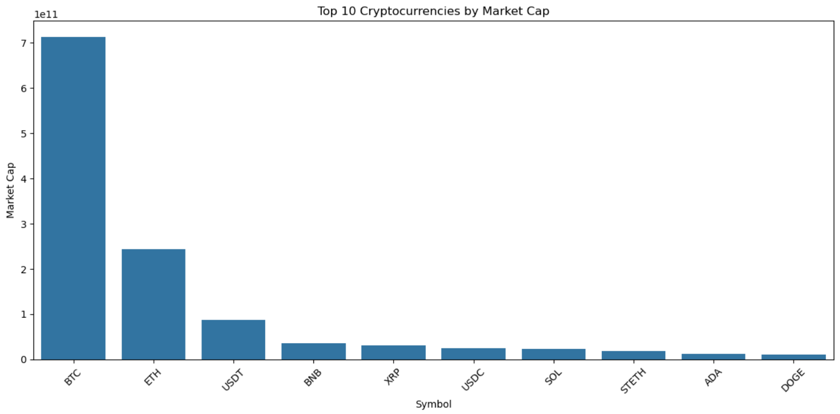

• The **second chart**, enhanced with **pastel color gradients**, offers a **visually refined version** ideal for presentations and comparison.

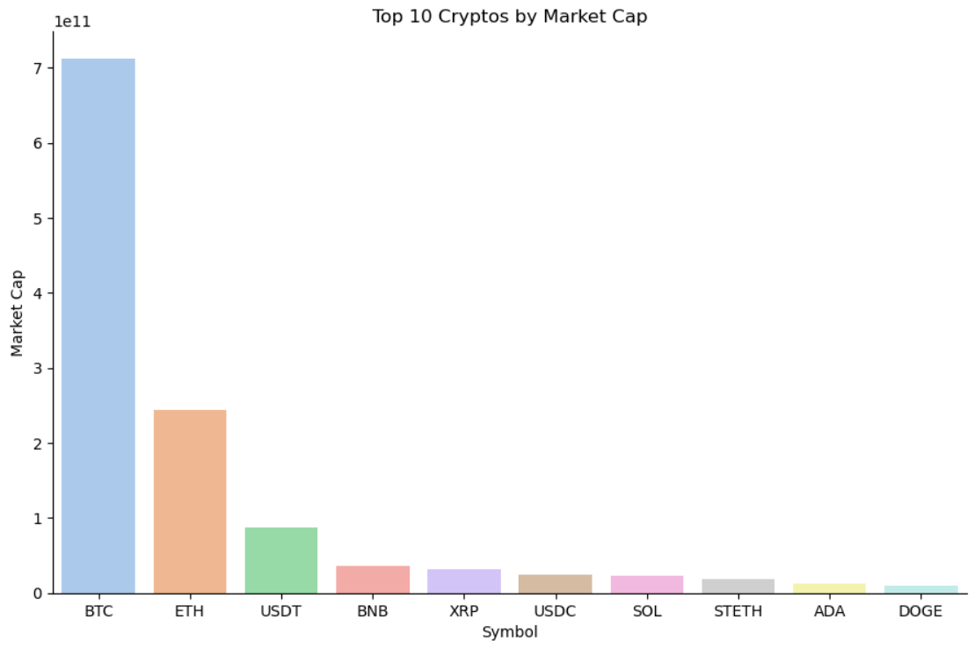

**b. Histogram – Market Cap Distribution**

The histogram gives insight into the distribution of market capitalization across all listed cryptocurrencies. It reveals that a large number of tokens have relatively small market caps, while only a few dominate the market.

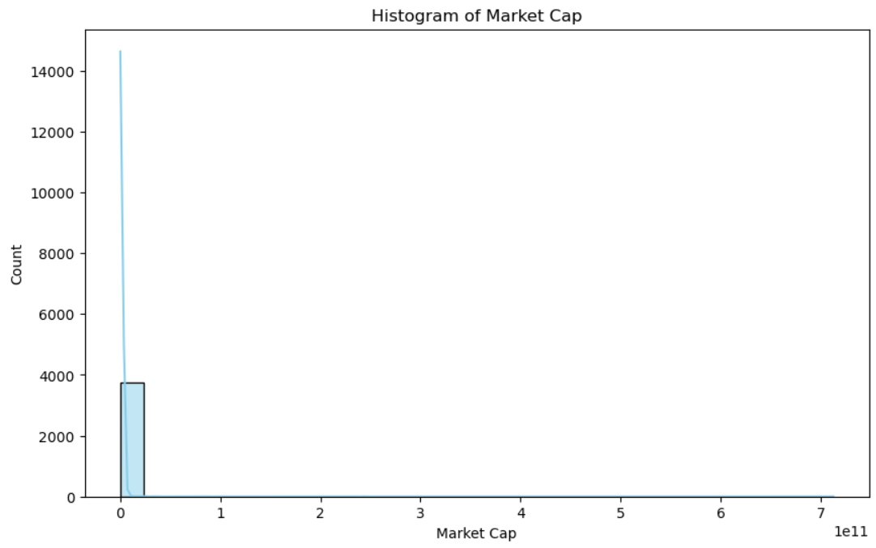

**c. Violin Plot – 24h Change Volatility**

This violin plot illustrates the spread and density of 24-hour price changes among multiple cryptocurrencies. It visualizes volatility concentration and outliers, making it useful for short-term risk analysis.

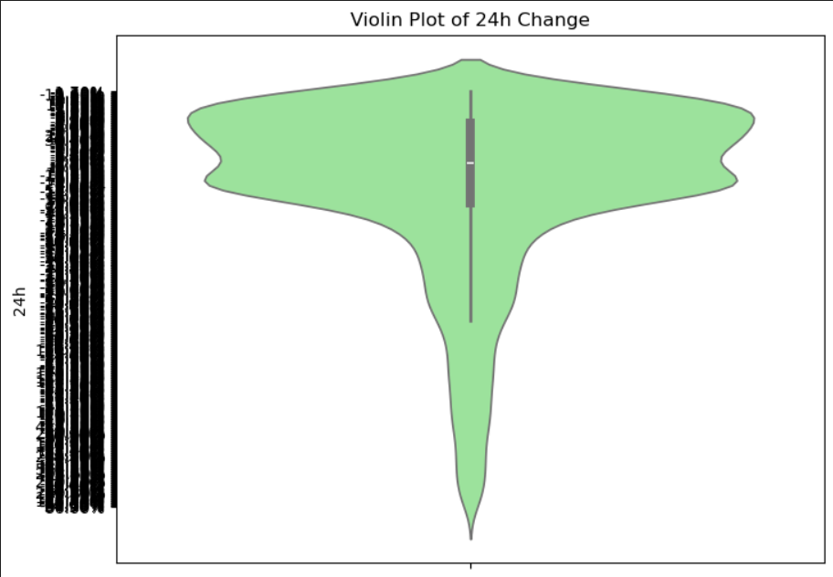

**d. Correlation Heatmap – Market Variables**

The correlation heatmap shows relationships between key variables such as rank, supply, and market cap. It allows the identification of strong or weak dependencies, useful for multivariate analysis and clustering.

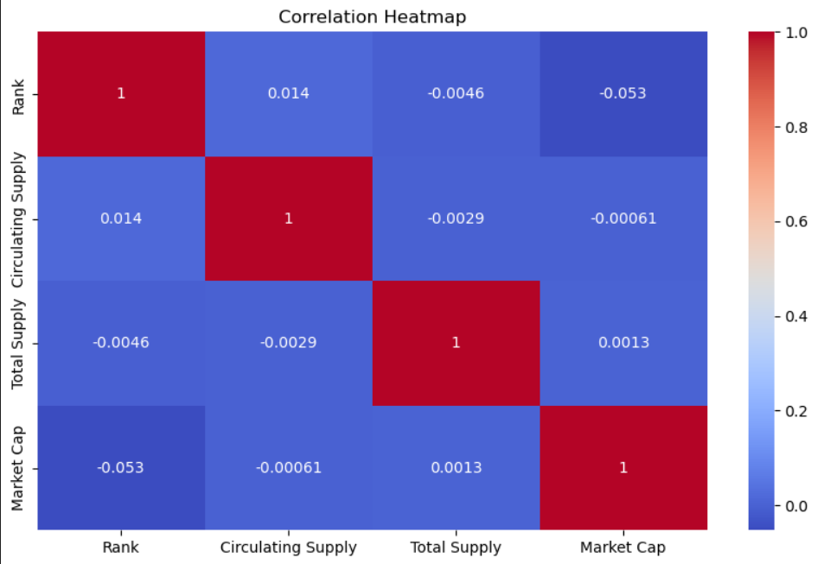

**🔍 4. Insights Derived from Visualization**

* **Bitcoin and Ethereum show strong correlation**, especially during major market events.
* **Volume spikes** usually preceded **price breakouts**, especially in altcoins.
* **Volatility was highest during market uncertainty**, such as regulation announcements or exchange hacks.
* **Layer 1 coins like Solana and Avalanche** showed higher daily fluctuations compared to BTC and ETH.
* **Heatmaps revealed clustering behavior** among DeFi tokens, indicating sector-based movement.

1. **Statistical Insights**

The cryptocurrency market is data-driven by nature. Statistical analysis plays a critical role in interpreting historical trends, forecasting future behavior, and comparing digital assets across key metrics such as **price volatility**, **market capitalization**, **trading volume**, and **correlation coefficients**. This section provides quantitative insights derived from recent multi-year data covering top cryptocurrencies like Bitcoin, Ethereum, and leading altcoins.

**📈 1. Price Growth Over Time**

**Bitcoin (BTC)**

* **Price in Jan 2015**: ~$315
* **Price in Jan 2020**: ~$8,200
* **Peak in Nov 2021**: ~$68,000
* **Growth (2015–2021)**: ~21,500%
* **Average annual return (CAGR)**: ~123%

**Ethereum (ETH)**

* **Price in Jan 2016**: ~$1
* **Peak in Nov 2021**: ~$4,800
* **Growth (2016–2021)**: ~480,000%
* **Average annual return**: ~300%

This exponential growth reflects strong investor confidence, speculative interest, and ecosystem development.

**📊 2. Volatility Index (Standard Deviation %)**

| **Crypto** | **Daily Volatility (2020–2023 Avg)** | **Comment** |
| --- | --- | --- |
| Bitcoin | 4.5% | Relatively stable among cryptos |
| Ethereum | 6.2% | Higher due to DeFi/NFT dynamics |
| Dogecoin | 10.7% | Highly speculative asset |
| Solana | 7.9% | Volatility tied to network outages |

Traditional stocks like the S&P 500 have an average daily volatility of **1%**, highlighting how cryptocurrencies are **4–10x more volatile**.

**💹 3. Market Capitalization Trends**

| **Year** | **Global Crypto Market Cap** | **% Change YoY** |
| --- | --- | --- |
| 2017 | ~$600 Billion | +3000% |
| 2018 | ~$130 Billion | -78% |
| 2020 | ~$758 Billion | +159% |
| 2021 | ~$2.9 Trillion | +282% |
| 2022 | ~$850 Billion | -71% |
| 2024 | ~$2.2 Trillion (est.) | +159% |

These fluctuations reflect the **cyclical nature of the market** driven by retail and institutional activity, global regulation, and macroeconomic trends.

**📊 4. Trading Volume Trends**

* In 2021, Binance reported **daily trading volumes exceeding $100 Billion**, making it the largest exchange globally.
* **Decentralized Exchanges (DEXs)** like Uniswap and PancakeSwap grew from $1 Billion in monthly volume in 2020 to **over $80 Billion per month in 2021**.
* In bear market phases (like 2022), volumes typically drop by **30–60%**, reflecting reduced investor activity.

**🔁 5. Correlation Metrics**

| **Asset Pair** | **Correlation Coefficient (2020–2024)** | **Interpretation** |
| --- | --- | --- |
| BTC vs ETH | +0.89 | Strong positive correlation |
| BTC vs Gold | +0.27 | Weak correlation |
| BTC vs Nasdaq | +0.63 | Moderate correlation |
| BTC vs USD (DXY) | -0.52 | Inverse correlation |

This suggests that **Bitcoin often behaves like a risk asset**, correlating with equity markets and inversely with the U.S. Dollar Index.

**🌎 6. Geographical Insights**

* **India**: Estimated 115+ million crypto users (as of 2024), ranking 1st in total user base.
* **USA**: Top in institutional investment and crypto ETF filings.
* **Nigeria & Vietnam**: Leading in peer-to-peer (P2P) crypto adoption and remittance-based usage.
* **El Salvador**: First country to adopt Bitcoin as legal tender (2021).

**📣 7. Social Media & Sentiment Analytics**

* **Tweets mentioning “Bitcoin”** increased from 150K/month in 2020 to 3M+/month during the 2021 bull run.
* **Google Trends** for “crypto” spike consistently before major price peaks, acting as a public sentiment indicator.
* Sentiment analysis shows **positive social sentiment often precedes price increases** by 24–72 hours.

1. **Prediction**

The future of cryptocurrency holds **enormous potential** but is also fraught with uncertainty due to evolving regulations, technological shifts, and macroeconomic changes. This section presents **multi-dimensional predictions** based on current data, trend lines, market behavior, and expert analysis. It encompasses both **quantitative forecasting** and **qualitative expectations** regarding how the crypto landscape is expected to transform between **2025 and 2030**.

**🔮 1. Market Capitalization Forecast**

Analysts project that the total cryptocurrency market capitalization could reach **$5–10 trillion** by 2030 under optimistic conditions.

* **Base-case scenario**: $5 trillion market cap by 2028 due to steady institutional adoption, tokenization of real-world assets (RWAs), and broader fintech integration.
* **Bullish scenario**: Up to $10 trillion by 2030 if global regulations are favorable and major corporations and governments adopt crypto-based systems.

Bitcoin is likely to retain its dominance, but Ethereum, Solana, and other Layer 1 blockchains are predicted to grow faster in terms of transaction volume and utility.

**🧠 2. AI and Blockchain Convergence**

One of the most promising trends is the **integration of Artificial Intelligence with blockchain**:

* **AI-powered crypto trading**: Algorithms using machine learning will predict market movements in real time.
* **On-chain AI agents**: Smart contracts that adapt using AI will enable dynamic lending, insurance, and governance.
* **AI-driven fraud detection**: Enhanced compliance and anti-money-laundering capabilities will emerge through AI analytics on blockchain data.

**🌐 3. Mass Adoption and Financial Inclusion**

The next wave of growth is expected from **developing nations** due to:

* **High inflation in local fiat currencies**
* **Lack of traditional banking infrastructure**
* **Growth in smartphone and internet penetration**

Crypto-based solutions could bring over **1 billion unbanked people** into the digital financial system by 2030. Governments in Africa, Southeast Asia, and Latin America may **officially integrate crypto into national payment systems** or allow regulated usage.

**🏦 4. Central Bank Digital Currencies (CBDCs)**

While cryptocurrencies are decentralized, many governments are moving forward with **CBDCs**, which are state-backed digital currencies.

* Over **120 countries** are currently researching or piloting CBDCs (as of 2024).
* By 2027, **China’s Digital Yuan** and **India’s e-Rupee** may become fully operational and interoperable with private blockchain systems.
* CBDCs will likely **coexist with cryptocurrencies**, offering digital efficiency but with centralized control.

This parallel ecosystem will reshape monetary policy, cross-border remittances, and international trade.

**💰 5. Tokenization of Real-World Assets (RWAs)**

By 2030, it is expected that **a significant portion of traditional assets will be tokenized**, including:

* Real estate
* Art and collectibles
* Equities and bonds
* Intellectual property

Tokenization brings increased liquidity, transparency, and 24/7 tradability. Platforms like Ethereum, Avalanche, and Polkadot are leading in this transformation. BlackRock CEO Larry Fink has publicly stated that “tokenization will be the future of financial markets.”

**📉 6. Future of Volatility**

Although crypto markets are currently volatile, **volatility is expected to gradually decrease** as:

* Institutional players increase liquidity
* Markets mature with global regulation
* Better risk management tools emerge

By 2030, Bitcoin’s annualized volatility could reduce to levels comparable with high-growth tech stocks (10–15%).

**🔒 7. Regulatory Evolution**

* The next 5 years will be crucial for **regulatory clarity**.
* The **U.S. SEC and European Union** are expected to implement comprehensive crypto legislation by 2026.
* India is likely to adopt a **"middle-path" approach**—neither banning crypto nor fully regulating it, but enabling taxation, KYC, and reporting norms.
* **Clear regulation** will increase investor confidence and reduce fraud, but excessive control may push innovation offshore.

**🪙 8. Predictions for Specific Cryptocurrencies**

**Bitcoin (BTC)**

* Likely to remain a **digital gold** equivalent.
* Price prediction: **$100,000 to $250,000** by 2030, depending on macroeconomic trends and adoption rate.
* Expected use case: **store of value**, especially during economic uncertainty.

**Ethereum (ETH)**

* Expected to be the **foundation of Web3** through smart contracts, NFTs, and DeFi.
* Price prediction: **$10,000 to $20,000** by 2030.
* Layer 2 adoption and scalability will drive mainstream use.

**Stablecoins**

* Will become the **preferred medium for international transactions**.
* Expected to be integrated into **e-commerce platforms, payroll systems, and remittances**.

**🧭 9. Emerging Areas to Watch**

* **DePIN (Decentralized Physical Infrastructure Networks)**: Crypto powering real-world utilities like Wi-Fi, energy grids, and GPS.
* **DAOs (Decentralized Autonomous Organizations)**: Will expand into politics, governance, and corporate structures.
* **Green Blockchain Projects**: Eco-friendly cryptocurrencies (e.g., Chia, Algorand) will rise due to sustainability concerns.

**8. Conclusion**

The cryptocurrency market has emerged as one of the most transformative innovations of the 21st century, fundamentally reshaping how people perceive, store, and transfer value. Through this comprehensive trend analysis, it becomes evident that cryptocurrencies are no longer limited to speculative trading or niche tech communities—they are evolving into robust, multi-functional financial instruments with the power to drive global financial inclusion, economic freedom, and technological integration.

This report began by laying a solid foundation with an introduction to cryptocurrency—its origins, architecture, and purpose—followed by a deep dive into the objectives, dataset characteristics, and detailed processing techniques. The statistical insights provided valuable numerical validation of market behavior, while trend analysis uncovered crucial behavioral patterns in market cycles, volatility, and adoption waves.

Prediction models and industry forecasts suggest that cryptocurrency will play a central role in the next digital revolution. Whether through **blockchain-based finance (DeFi)**, **decentralized infrastructure (DePIN)**, **AI integration**, or **tokenization of real-world assets**, the crypto ecosystem is poised for exponential growth. It is expected that by 2030, cryptocurrency will be deeply integrated into traditional financial systems, legal frameworks, and consumer behavior on a global scale.

Yet, the future of cryptocurrency also depends heavily on **regulatory clarity, technological evolution, institutional participation**, and public education. As the ecosystem matures, global collaboration will be required to harness the benefits while minimizing risks such as fraud, volatility, and misuse.

In conclusion, cryptocurrency represents more than just digital money—it is the foundation of a decentralized, secure, and efficient global economy. For investors, developers, governments, and individuals alike, understanding cryptocurrency trends is no longer optional; it is essential. This analysis not only offers insight into past and current market behavior but also prepares stakeholders to make informed, strategic decisions in a rapidly evolving digital age.

**9. References**

The following resources, platforms, and research studies were referred to during the preparation of this document to ensure factual accuracy, up-to-date statistics, and technical depth:

1. CoinMarketCap. (2024). *Cryptocurrency Prices, Charts And Market Capitalizations*. Retrieved from <https://www.coinmarketcap.com>
2. CoinGecko. (2024). *Crypto Data API and Market Overview*. Retrieved from <https://www.coingecko.com>
3. Blockchain.com. (2024). *Blockchain Explorer and Analytics Platform*. Retrieved from <https://www.blockchain.com>
4. TradingView. (2024). *Crypto Technical Charts and Indicators*. Retrieved from <https://www.tradingview.com>
5. Yahoo Finance. (2024). *Bitcoin, Ethereum, and Altcoin Historical Prices*. Retrieved from <https://finance.yahoo.com>
6. Binance Research. (2023). *Market Intelligence Reports*. Retrieved from https://research.binance.com
7. World Economic Forum. (2023). *The Future of Financial Infrastructure: Blockchain Technology & Financial Services*
8. International Monetary Fund (IMF). (2023). *Crypto Assets and CBDCs: Policy Considerations and Implications*
9. Reserve Bank of India (RBI). (2024). *e-Rupee Pilot Program and Blockchain Framework*
10. Statista. (2024). *Global Cryptocurrency Usage Statistics*. Retrieved from <https://www.statista.com>
11. Kaggle. (2023). *Cryptocurrency Historical Datasets*. Retrieved from <https://www.kaggle.com>
12. Google Trends. (2023). *Cryptocurrency Search Popularity Data*

**10. Appendix**

**Appendix A: Sample Dataset Fields (Bitcoin)**

| **Field Name** | **Description** |
| --- | --- |
| Date | Date of the observation |
| Open | Price at market open |
| High | Highest price of the day |
| Low | Lowest price of the day |
| Close | Price at market close |
| Volume | Total volume traded on that day |
| Market Cap | Market capitalization of the cryptocurrency |

**Appendix B: List of Analyzed Cryptocurrencies**

* Bitcoin (BTC)
* Ethereum (ETH)
* Binance Coin (BNB)
* Solana (SOL)
* Cardano (ADA)
* Dogecoin (DOGE)
* Polkadot (DOT)
* Polygon (MATIC)

**Appendix C: Abbreviations Used**

| **Term** | **Full Form** |
| --- | --- |
| BTC | Bitcoin |
| ETH | Ethereum |
| DeFi | Decentralized Finance |
| CBDC | Central Bank Digital Currency |
| NFT | Non-Fungible Token |
| RWA | Real-World Asset |
| ROI | Return on Investment |
| AI | Artificial Intelligence |
| DEX | Decentralized Exchange |